C1769261 Tom Clare Java Coursework Report

In this report I will be showing the 4 different sections of the Object Orientated Java Coursework. These sections are Removing Stop words, merge sort, insertion sort and finally the circular array implementation.

The program design is very simple. The remove stop words class just reads all of the words from the 2 given text fields and then returns the words in GPT2 minus words that appear in the stop words file.

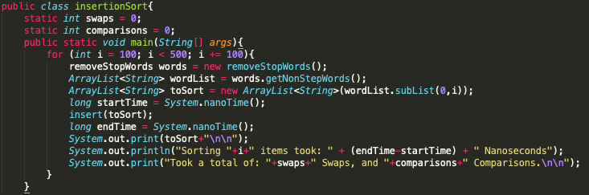Both of my sorting programs have the same start. They both call the remove stop words function to get the list of strings for them to sort.

They then start a loop to short various lengths of that list. In this they will print the sorted list the time taken for each sort and the number of elements in that particular sort. Then in addition it will print the number of swaps and comparisons made in the sorting. With both the number of swaps and comparisons being a static variable creating in the instantiation of the class.

The insertion sort works by iterating through he given list and moving the current item down the list until it finds a larger item at which point it will instead move that item down the list and so on until at the end of the first loop the largest item is in the correct place. This then continues until all the items are inserted into the correct position.

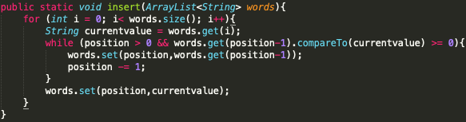

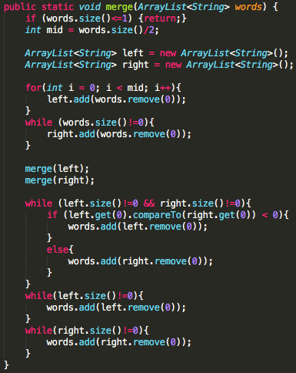The merge sort works by diving the list into half each time is iterates through, it then recursively divides these section into smaller sections for sorting.